**PSHCE at Elthorne Park High School**

* + - * The curriculum allocation for PSHCE is 1 hour per week for all year groups.
      * The PSHCE curriculum spirals and each year students will complete units of work helping them navigate their teenage years and make positive choices about their futures.
      * EPHS PSHCE strands are: Living in the Wider World; Careers Education, Information, Advice & Guidance; Relationships & Sex Education; Health; Safety & Wellbeing; Respect, Tolerance & Individual Liberty.
      * PSHCE is taught by teachers who will assess students’ progress in the subject and ensure they can recall important facts as well as supporting their wellbeing and personal development.
      * EPHS prides itself in taking an inclusive approach to PSHCE and ensuring that all students feel they are provided with a safe space to discuss important issues relating to their own beliefs, experiences and aspirations for the future.

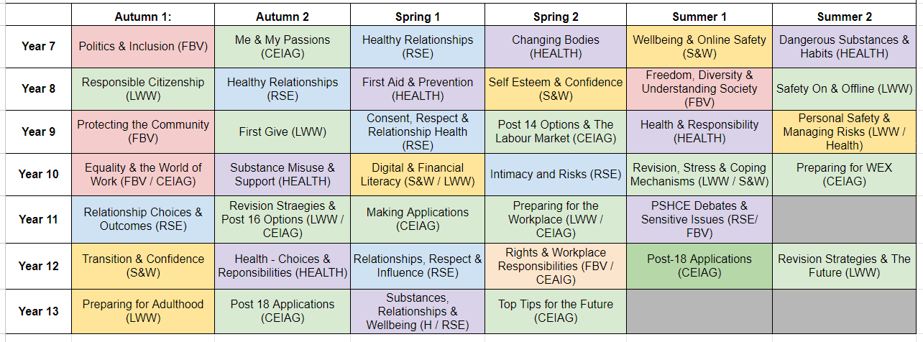**Overview of Topics KS3 - 5**